**al-`Ayni, Yusuf (1927-)**

A playwright, actor, and director, Yusuf al-`Ayni was instrumental in the development of Iraqi theatre from the 1950s through the 1970s. His three-decades-long career coincides with the advent and flourishing of a professional theatre in Iraq, one primarily concerned with addressing political and social concerns. He emerged during a time of political turmoil under the British-supported monarchy and his tenure coincided with the establishment of the independent Iraqi state in 1958 and later the rise of the Baathists and Saddam Hussein. In the late 1960s, al-`Ayni initiated the movement within Iraq that combined classical Arabic forms with techniques from Western political theatre, particularly those of Bertolt Brecht.

Al-`Ayni grew up in a working-class neighborhood in Baghdad and studied theatre at Baghdad’s Institute of Fine Arts. In 1952, he co-founded the first professional theatre company in Iraq, *al-Masrah al-Hadith* (the Modern Theater) troupe, which would dominate that country's theatre scene for the next three decades. As a playwright, he engaged Arabic and Iraqi politics and events from a Marxist perspective. The one-act *Ra’s al-Shilila* (*The End of the Thread* [1951]), which has been translated as *Where the Power Lies*, serves as an early example of his commitment to social justice. In it, a poor, old man’s simple request is denied by corrupt government officials until he chances upon the business card of an influential personage, which in itself impresses the officials into compliance. Other notable plays include *Ana Ummak Ya Shakir* (*I am Your Mother, 0 Shakir* [1958]), which celebrates a family that resists an oppressive monarchical regime, *Al-Miftah* (*The Key* [1967-68]), which urges political action over the blind observance of outdated tradition, and the anti-imperialist *Al-Kharaba* (*The Ruin* [1970]).

Al-`Ayni was acclaimed as an actor on the stage and screen and frequently appeared in his own works and directed for his company. His performance of the lead role in 1957 in one of the first and most popular Iraqi movies, *Sa’id Effendi* (*Mr. Sa’id*), increased his renown. The film’s veiled political message is consistent with Al-`Ayni’s career as a whole. In his various capacities as playwright, actor, director, and teacher, he was dedicated to advancing a theatre of the people.

**List of Works**

al-`Ayni, Yusuf (1981) *Ashr Masrahiyyat min Yusuf al-'Ani* (*Ten Plays from Yusuf al-`Ayni*), Beirut: al-Mu' assasah al-'Arabiyya lil-Dirasat wa-1 Nashr.

Jayyusi, Salma Khadra (ed.) (2003) *Where the Power Lies*, trans. Lena Jayyusi and Thomas G. Ezzy, *Short Arabic Plays: An Anthology* 1-19, Northampton, MA: Interlink.

Jayyusi, Salma Khadra and Roger Allen (eds.) (1995) *The Key*, trans. Salwa Jabsheh and Alan Brownjohn, *Modern Arabic Drama: An Anthology* 253-288, Bloomington: Indiana UP.

**References and further reading**

al-`Ayni, Yusuf (1979) *Al-Tajribah al-Masrahiyya* (*The Theater Experience*), Beirut: Al-Farabi.

--- (Oct. 1996) 'Al-Waqt al-ladhi lam Yadhab Suda' ('The Time That Has Not Passed in Vain'), *Al-Iraq* 24:4.

Yousif, Salaam (1997) 'The People's Theater of Yusuf Al-Ani', *Arab Studies Quarterly* 19 (4): 65-93.

James Al-Shamma

Al-`Ayni Interview in Arabic:

<http://www.youtube.com/watch?v=JSbcuWXa9yo>

Photo 1 source:

<http://www.aliabdulameer.com/inp/view_printer.asp?ID=521&AUTHOR=>

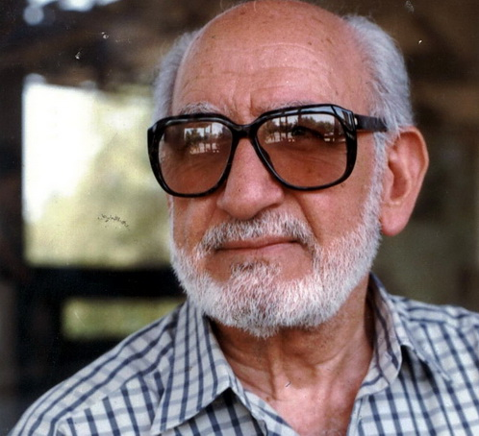

Photo 2 source (unfortunately, this link is broken; I have no other information about the photograph):

<http://hassanalmoslih.maktoobblog.com/4727/%D9%8A%D9%88%D8%B3%D9%81-%D8%A7%D9%84%D8%B9%D8%A7%D9%86%D9%8A/>

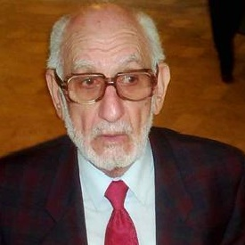

Photo 3: “Iraqi actors Yusuf Al-Ani and Azadohi Samuel perform in a play in Baghdad.”

Source:

<http://mawtani.al-shorfa.com/en_GB/articles/iii/features/2008/02/17/feature-01>

